CONNECTING CULTURES

Things we have learnt about Poland…

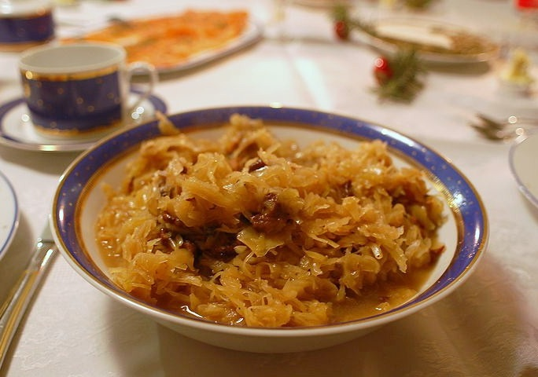
- BIGOS is a Polish dish of finely chopped meat of various kinds stewed with sauerkraut and shredded fresh cabbage.

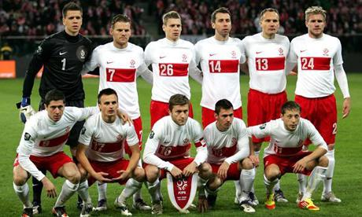

- As in Spain, the most popular sport in Poland is FOOTBALL!

- In Siedlce, the most important traditions and festivals are:
Days of Siedlce and St. Stanislaw

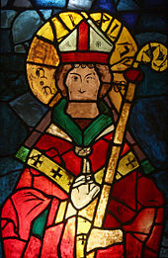

- SIEDLCE is a city in eastern Poland with 76,585 inhabitants
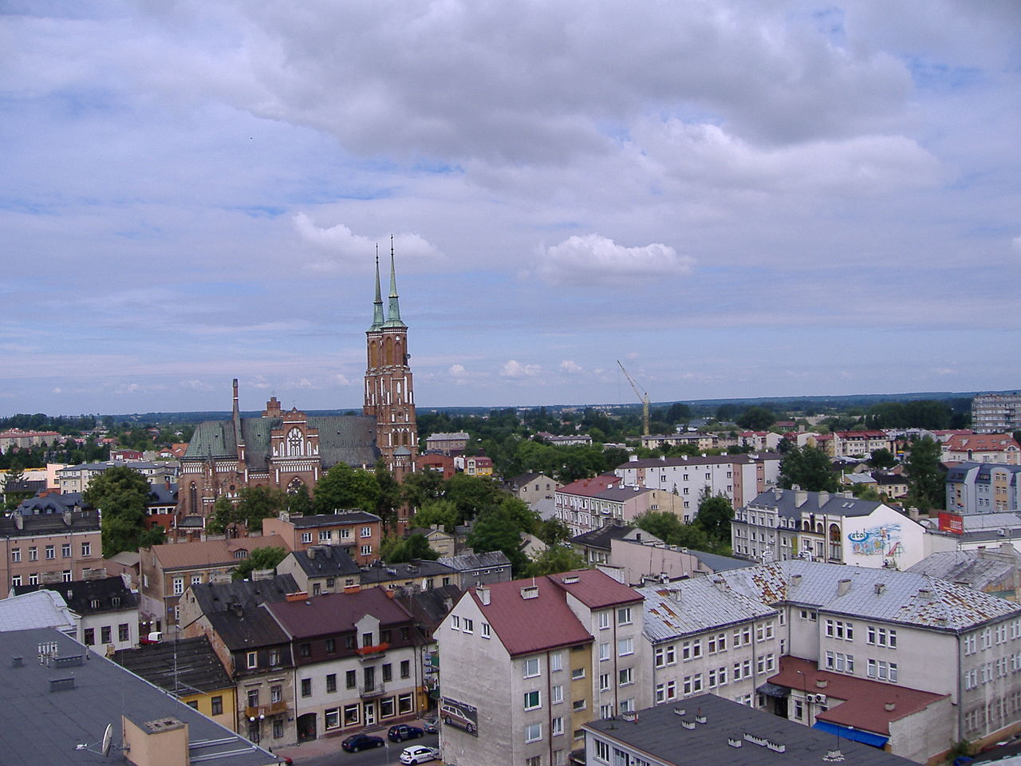

Siedlce in the map

- In SIEDLCE there are more than 160 schools, while in Alhama de Murcia there are 7 primary schools!
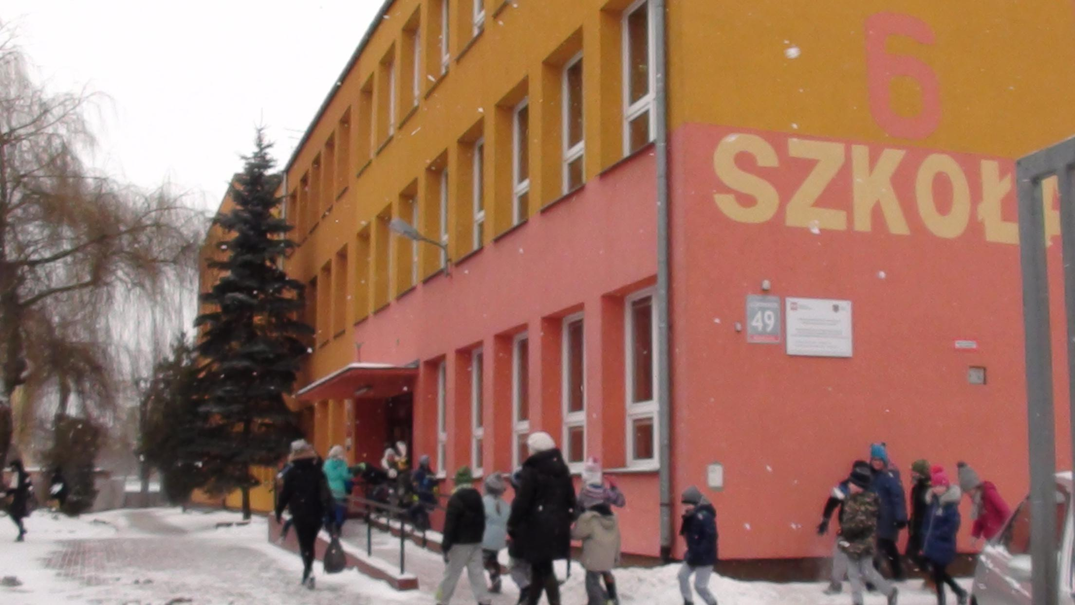

Wladyslaw Broniewski School
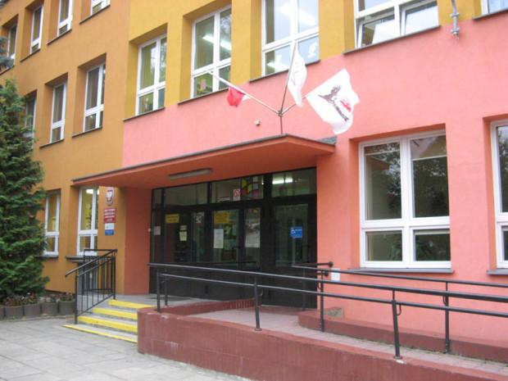

- In Polish class there are 15 students while in Spanish class there are 21!
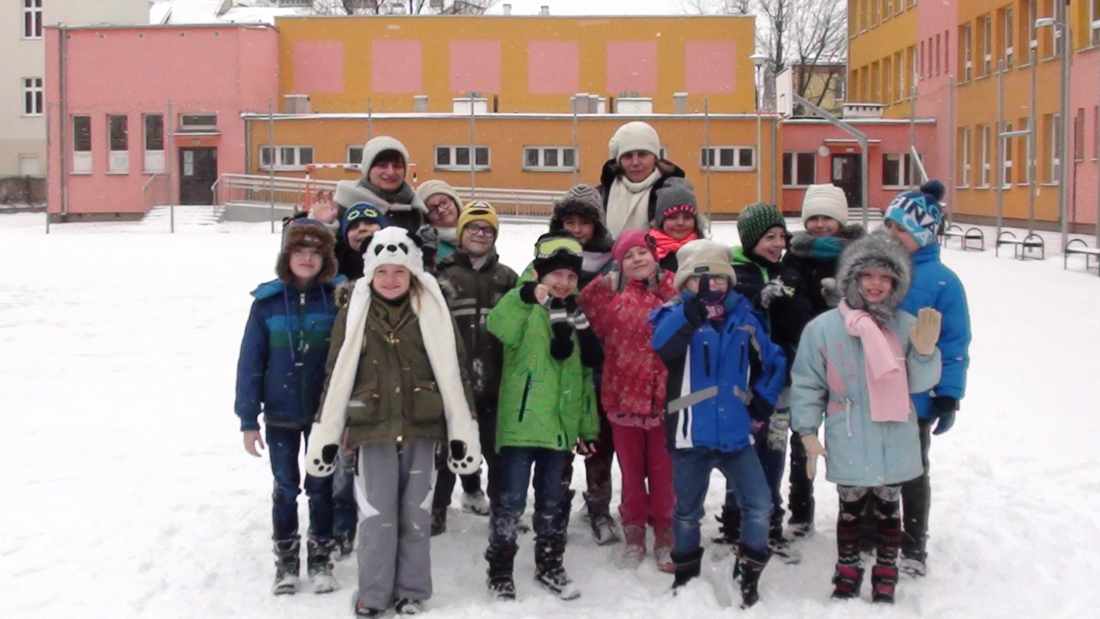

- We have learnt a lot about SIEDLCE in this video:

Sieldce is my town

